Emergency Medicine Clerkship
Marian University 4th Year
Hendricks Regional Hospital
Clerkship Director: Millie Schultz, MD
Draft from April 2023

This Clerkship Description is designed for Marian University School of Medicine Students at Hendricks Regional Health. It references the Emergency Medicine Core Clerkship Syllabus from MU-COM and AAMC.org as noted with corresponding Entrustable Professional Activity (EPA) numbers.

Big Picture

This clinical clerkship introduces MS4 students to the field of Emergency Medicine in a busy Community hospital. The breadth and acuity in our field is a fundamental part of every clinician’s medical knowledge regardless of specialty.

Understanding what you are taught this month requires a solid knowledge base from your third year clerkships. Every patient you will see on this rotation will require you to apply some medical knowledge from your previous medical training.

The expectations for the clinical portion of this rotation are listed below. Please note that you should strive to function as much as an independent provider as you safely can. Your challenge is to push yourself to make decisions and treatment plans as though you were acting alone. These will then be presented to your attending. Your evaluation will not primarily focus on the accuracy of your treatment plans but more so the content & defense of your differential diagnoses. The themes that will be reinforced for you during each shift will be to consider “WORST FIRST” and always considering the “CAN’T MISS” diagnoses. Only thereafter can you consider the most common diagnoses.

Another critical skill that you must practice on this clerkship is gauging acutely sick/ gravely ill patients from stable patients. Regardless of the clinical setting in which you practice, you are responsible for your patients at any acuity. You’ll need to know how to identify critical illness and respond accordingly.

Expectations

The approach of each patient will be a focused history and physical exam based on chief complaint. You will be expected to perform the following tasks while on shift:

-Emergency Physicians take punctuality very seriously. Be ready to see patients when your shift starts.

-Sign up for patients without asking. Aim for 1 patient per hour.

-Without being asked or prompted, you will be expected to introduce yourself to the patient and perform your history and physical exam (except genitourinary exams) independently (EPA 1). The only exception is if you are concerned that a patient’s acuity cannot safely wait, in which case you must notify your Attending immediately (EPA 10).

-Your differential diagnosis is the compilation of conditions you’ve considered when evaluating a patient. Push yourself to make the most thorough differential diagnosis (EPA 2). If you haven’t considered a diagnosis, you will miss it. As an Emergency Medicine Specialist, your function this month is to find emergencies & address them. You must consider every potential emergency for a patient’s chief complaint (EPA 10).

-Your attending is available to answer questions about diagnostic and management considerations but you will have to get familiar with online resources to answer your own clinical questions to succeed as a physician. My go to resources are shown below (EPA 7).

-Unless the patient is in extremis or needs an Attending immediately, you are expected to enter orders for testing, treatment, and disposition independently (EPA 3 & 4). Enter your orders into Epic after your patient encounter. They will be sent to your Attending and will be edited. Consider this an opportunity to commit to your plan. It’s more challenging than you think! You will not be graded on the accuracy of your plan as long as you can defend your plan.

-Your data and plan will be presented to your Attending (EPA 6). Consistent practice on such presentations is what organizes the extensive amount of medical information you’ve learned into something that applies to actual medical care.These presentations are difficult for medical students because it’s a completely different type of presentation than what you’re used to when rounding. The way we think about patients is different than providers in inpatient medicine and in clinic. Instead of a comprehensive assessment of each patient, we frame our encounter around a particular problem, investigating that problem, and treating that problem. Often we have to investigate and treat problems simultaneously. Sometimes there are multiple problems that need to be addressed. Some problems require more thorough assessments than others (ex. The 80 year old female with generalized weakness is going to require a more comprehensive history and exam than the teenager with a splinter). The biggest challenge for medical students in this rotation is knowing which information is pertinent and which can be excluded from the presentation. This is a difficult skill that takes years to perfect, so you should give more thorough presentations than you witness Attendings present to each other. After your presentations, your Attending should give real time feedback.

-Each patient encounter will have a Medical Student note from you in their medical record (EPA 5). This is discoverable in their chart. People will likely reference your note for subsequent care decisions so this is a very important part of the encounter. As you can imagine, our charting is different than what you’ve seen on wards and in clinic. Charting should demonstrate your thought process with each medical decision. It defends what you’ve done and communicates to other providers why you did or didn’t order certain diagnostics or therapies. There are various strategies that are important to charting that aren’t intuitive. You’ll be getting charting feedback throughout your career regardless of specialty.

-You will be expected to call most consultants for your patients (EPA 9). This is a difficult skill that takes years of practice. It is a stressful part of the medical student experience, but the sooner you get the practice, the more prepared you’ll be next year. Your attending will help you prepare for each consult. See some tips provided by EMRA below.

-If circumstances allow, we will review the skills needed to conduct a safe patient changeover (EPA 8).

-When procedures are done in the department, we try to optimize your exposure. If time allows, research/review the procedure as much as you can beforehand. Depending on the procedure and physician comfort level, you may be allowed to perform the procedures under direct supervision (EPA 12).

-A critical part of this rotation is learning how to feel empowered in an environment that can be busy and intense. You are an integral member of the care team. Get your hands dirty. A great way to help us without being in the way for sick patients is getting them on the monitor or putting oxygen on the patient. You are expected to be at every Resuscitation. Keep your ears open for all EMS calls.

-Always be very respectful to other team members (EPA 9). In the Emergency Department, we are not sequestered in offices to do orders or charting. We are working alongside the people performing our orders.

-If you ever witness a system failure or safety issue that needs to be addressed, please inform your Attending or Millie Schultz (EPA 13). Patient and employee safety are the department’s first priorities, always. Quality Improvement is another priority and your feedback is important to us. The culture is that team members feel empowered to speak up when something doesn’t seem right.

Resources

Note: Previous students have told me the following resources were most helpful studying for the EM NBOME exam.
-UWorld
-Board Question Collections
-Core EM Apple Podcast
-EM Clerkship Apple Podcast
-Roshkast test cases

The following are great for reference while on rotation/ clinicals.

Emergency Medical Services | Tintinalli's Emergency Medicine: A Comprehensive Study Guide, 9e | AccessMedicine
This is THE go-to textbook for Emergency Medicine.

Rosen's Emergency Medicine: Concepts and Clinica - 9780323757898
This is another widely used Emergency Medicine textbook.

EM:RAP
This is the most widely used reference for CME in Emergency Medicine. However, they have an EXCELLENT Primary Care & Urgent Care section of the podcast. Very strongly recommend.

LITFL.com
This is an excellent free resource for quick reference on shift.

UptoDate.com
This is available to you for free at Hendricks. Click Resources tab in Epic -> UptoDate.

Syllabus Readings - Emergency Medicine Clerkship - LibGuides at Marian University
Clutch access to lots of EM resources including those above for free through your school. I like EM Case Files a lot.

M3 Curriculum (saem.org)
M4 Curriculum (saem.org)

I am really looking forward to guiding you as you experience the rewarding transition of thinking about medicine to actually practicing medicine.

*Please note that the shelf requirements for your clerkship will be communicated to you through Marian University SOM.

Tips for Presenting Your Patient:

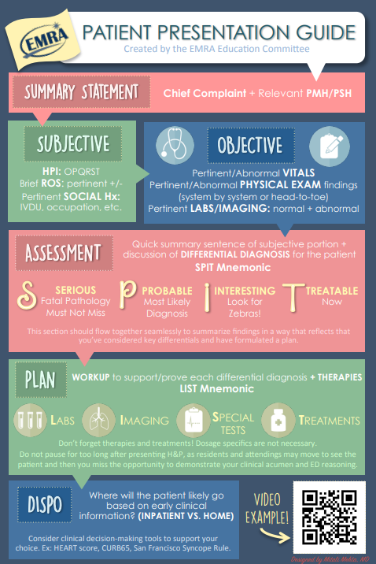

Tips for Calling a Consult:

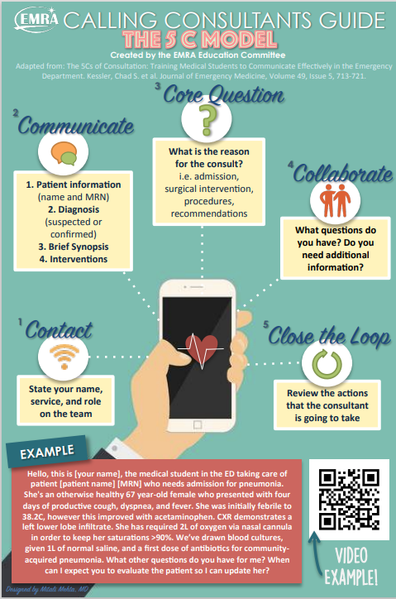

Transitions of Care EMRA

Hand-Off Tools:
Remember CODE STATUS!
IPASS:
Illness severity: Stable, “watcher,” unstable
Patient Summary: HPI, ED course/Ongoing assessment, Plan
Action List: “To-do”
Situation Awareness and Contingency Planning: “If this, then do that.” Give your colleagues an idea of what to do if an event occurs.
Synthesis by Receiver: Person taking the sign out does a “readback” of what they heard. Restate key actions. Also, the time to ask questions.
SBAR
Situation: Clearly and briefly define the situation
Background: Provide clear, relevant background information that relates to the situation.
Assessment: A statement of your professional conclusion.
Recommendation: What do you need from this individual? What to do and contingencies.
SHOUT
S: Sick or not Sick
H: History and Hospital Course
O: Objective Data
U: Upcoming plan, disposition
T: To do

The following are copied from the Marian University Syllabus for Emergency Medicine:

Student Learning Outcomes

At the conclusion of these courses, students will demonstrate an ability to:

• History & Physical: Employ a hypothesis driven approach to independently gather an accurate and appropriately complete history from and correctly perform a relevant and appropriately physical examination on emergency patients with core chief complaints and diagnoses (EPA 1).

• Clinical Reasoning: Integrate patient data and employ cognitive de-biasing strategies to formulate an appropriately broad prioritized differential and working diagnosis for emergency medicine patients with core chief complaints and diagnoses (EPA 2).

• Diagnostic Testing: Use a hypothesis driven, evidence-based, and cost-effective approach to select and interpret diagnostic tests for emergency medicine patients with core chief complaints and diagnoses (EPA 3).

• Documentation: Accurately and effectively document the clinical encounter for emergency medicine patients (EPA 5).

• Acuity: recognize a patient requiring urgent or emergent care and initiate appropriate evaluation and management (EPA 10).

• Procedures: Perform general procedures of a physician (CPR, Bag and Mask Ventilation, Venipuncture, IV line insertion) (EPA 12).

To Do:

- Preceptor Competency Evaluation Form
  - The Preceptor Competency Evaluation Form must be submitted according to the procedures outlined in the Clerkship Guidebook. If the preceptor of record is incorrect in New Innovations, please contact the Clerkship Coordinator so this can be corrected. If a student consistently worked with more than one preceptor in the specialty of the clerkship, two or more evaluation forms can be accepted, and the scores will be averaged.
  - If a student receives a ‘Does not meet’ on any of the seven evaluation competencies, the maximum letter grade earned will be a ‘Pass.’
  - If a student receives ‘Does not meet’ on two or more of the seven evaluation competencies, the evaluation is unsuccessful and the grade will be ‘Fail’.
- Request mid-rotation feedback from preceptor.
  - Utilize this information as formative feedback and work to implement any recommended improvements.
- Complete Emergency Medicine modules assigned in the Learning Objective schedule (Appendix A). All assigned modules are to be completed by the end of the rotation.
- Be responsible for your behavior and should at all times maintain the level of professionalism, academic honesty and integrity that a state medical licensing board expects.
- Complete Longitudinal Procedural Logs for procedures as appropriate to the rotation

Entrustrable Professional Activities (EPAs) Language in Medical Schools’ Learning Objectives (aamc.org)

